OUR PARTNERS
Centre 404 works in partnerships with other organisations to improve the lives of family carers.
We recognise that, in order to make the greatest difference to family carers’ lives is not to work in isolation but to work with others.
This has been our approach for getting things done for many years.
We also understand that to achieve change at societal level, charities must work not only with each other but in partnership with statutory and voluntary organisations and also private and corporate agencies in order to effect real progress and improve the lives of people with a learning disability and their family carers.

We are currently working with the following partners:

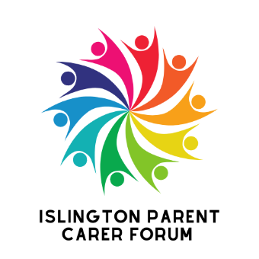
The Islington Parent Carer Forum
The Islington Parent Carer Forum is a parent-led group for parents of children and young people (0 to 25) with SEND. They have bi-monthly meeting where parents have a chance to participate in consultations and comment on developments in local and national disability services. Centre 404 works in partnership with the Forum to support and maintain their grant funding and facilitate the activities.
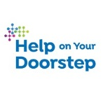
Help on Your Doorstep
Centre 404 is one of the specialist partners of the Islington’s umbrella organisation ‘Help on Your Doorstep’. We work together to support Islington families with a member with a learning disability or autism. You will see us at their partnership meetings and some of their door-knocking events.

Islington Carers Hub
We work in partnership with the Islington Carers Hub to provide joint wellbeing events and activities for all family carers in Islington. We also refer family carers to each other. Look out for some of these joint events during the Carers Week!

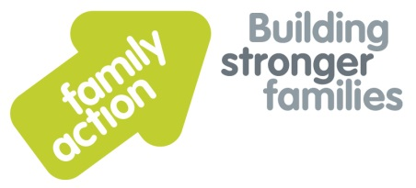
Islington SEND Community Service

We work together to support parents of children with any special educational need or disability (SEND) in Islington. The SEND Community Service has a regular slot at the Islington Parents Forum meetings facilitated by Centre 404. We make referrals to each other.

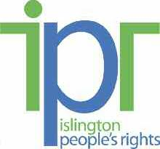
Islington People’s Rights

We work together to support parents and family carers of children with learning disabilities and autism around benefit advice and support and income maximisation. We make referrals to each other.

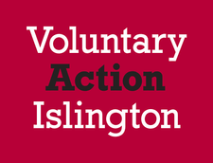
Voluntary Action Islington

VAI offer a wide range of services for local organisations, small groups, and volunteers at all stages of their development. These services range from one-to-one support, through to training and money management. Centre 404 works with VAI to share information and to promote events and community activities.

Camden Special Parents Forum

The Special Parents Forum is open to all parents and carers in Camden with a child/young person with special needs and disability. The forum meet to talk about local issues that are important to families. Centre 404 links with family carers to prepare and provide information on transition to Adult Social Care.

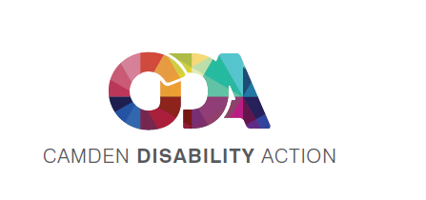
Camden Disability Action

CDA is a user-led organisation which aims to promote the equality of deaf and disabled people living or working in Camden. The CIL (Centre for Independent Living) is a new service, run and controlled by Deaf and disabled people. Centre 404 works with Camden Carers Service as part of the reference group to ensure the voice of carers and people with learning disabilities are heard through groups and representation.

Camden Carers Service
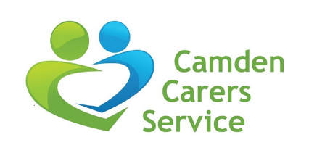
Camden Carers offers information, advice and support to unpaid adult carers (18+) living, working or studying in Camden, or caring for someone who lives in Camden. We communicate regularly to identify the needs of those with support and to cross-refer families.

Swiss Cottage Special Needs School and the Winch – Camden

We provide a monthly drop-in and information sessions for parents and family carers at Swiss Cottage Special Needs School and the Winch in the Hamsptead and Kilburn area.

Arcadian Gardens Surgery, Haringey

We have linked with this GP practice to help families who need specific support and information in Haringey about activities for people with learning disabilities. We have run two drop in events with caseworkers at the surgery to help families with support and activities and volunteering opportunities in Haringey.

The Haringey Carers Coffee Morning

This long established group is run by committed volunteers and is open to all carers. A lovely safe space with good coffee and home-made cakes, newspapers and fresh flowers, where Carers can enjoy talking amongst themselves and supporting each other. Every Thursday – 10.30am-12.30pm. We attend weekly and offer a casework service to carers of people with learning disabilities and autism. We also provide signposting, information and support.

Community Engagement, Haringey Advice Partnership

They help and support local residents by providing information, advice and guidance enabling people to make informed choices. They provide stalls and free health and wellbeing workshops in community venues and we have worked closely in partnership with them to promote and provide workshops for carers in the borough.

The Haringey Carers Forum

Provides an opportunity for carers of people with learning disabilities to have their say on a range of issues that affect them and the people they care for and to receive information on changes and services in the borough. We attend regularly and ensure access for carers to our casework service.

Local Area Organisers, Haringey

They work with local residents to ensure people can maximise the quality of their lives whatever their circumstances. We have worked closely with this service around information sharing, signposting, making referrals and event provision.

If you would like to become a partner of the Centre 404’s Supporting Families service please contact Beatriz on beatriz@centre404.org.uk

